PROJECT REPORT: BEC PHISHING DETECTION USING MACHINE LEARNING

DEPARTMENT OF CYBER FORENSICS AND INFORMATION SECURITY (CFIS)

NAME:
SEMESTER: 5TH
REGISTRATION NO.:
SESSION: 2025-26

Under the guidance of: Dr. Partha Sarathi Goswami
Lecturer in Computer Science and Technology
Secretary, Academic Council
Behala Government Polytechnic

Department of Cyber Forensics and Information Security
Behala Government Polytechnic
(Affiliated to West Bengal State Council of Technical & Vocational Education & Skill Development, Government of West Bengal)
756, U. N. Banerjee Road, Parnasree, Kolkata-700060

CERTIFICATE OF APPROVAL
This is to certify that this report of Diploma 5th semester project, entitled "BEC Phishing Detection Pipeline using Machine Learning" is a record of group work, carried out by Akash Basak, Subhamita Mondal, and Abhiraj Kumar Rajak under the supervision and guidance of Dr. Partha Sarathi Goswami, Secretary, Academic Council, Behala Government Polytechnic.
In my opinion, the report in its present form is in partial fulfilment of all the requirements, as specified by the Behala Government Polytechnic and as per regulations of the West Bengal State Council of Technical & Vocational Education & Skill Development, Government of West Bengal. In fact, it has attained the standard, necessary for submission. To the best of my knowledge, the results embodied in this report, are original in nature and worthy of incorporation in the present version of the report for Diploma programme in Cyber Forensics and Information Security of Behala Government Polytechnic in the session 2025-26.
It is understood that by this approval the undersigned does not necessarily endorse or approve any statement made, opinion expressed or conclusion drawn therein, but approve this project report for the purpose for which it is submitted.

______________________________  Dr. Partha Sarathi Goswami  Project Supervisor  Department of Cyber Forensics and Information Security  Behala Government Polytechnic | ______________________________  Dr. Sudipta Kr Ghosal  Head of the Department  Department of Cyber Forensics and Information Security  Behala Government Polytechnic
______________________________  Dr. Partha Sarathi Goswami  Secretary, Academic Council  Behala Government Polytechnic | ______________________________  Sri. Narendra Nath Sinha  Principal-in-Charge  Behala Government Polytechnic

ACKNOWLEDGEMENT

We feel extremely glad in presenting our final year project at Behala Government Polytechnic, Kolkata, in the partial fulfilment of the requirements for the diploma of in Cyber Forensics and Information Security.
We would like to express our deepest gratitude to our project mentor and coordinator, Sayuj Sur, for his constant guidance, technical support, and valuable insights that were instrumental in the completion of this project.
We would like to specially thank our guide Dr. Partha Sarathi Goswami, Secretary, Academic Council, Department of Cyber Forensics and Information Security for his vigilant supervision and his constant encouragement. Without his enthusiasm, this work could not have been possible.
Finally, we would like to thank our parents. Without their love, patience and support, we would be unable to complete this project.

Project Members/Contributors:
Name | Registration Number | Role
Akash Basak |  | Lead Developer & Data Analysis
Abhiraj Kumar Rajak |  | Feature Engineering & Documentation
Subhamita Mondal |  | System Architecture & Testing

Table of Contents
Sl. No. | Section / Chapter | Page No.
 | CERTIFICATE OF APPROVAL | 1
 | ACKNOWLEDGEMENT | 2
 | ABSTRACT | 4
1 | INTRODUCTION | 5
2 | SYSTEM ARCHITECTURE | 5-6
3 | METHODS AND LIBRARIES USED | 6-7
4 | TECHNICAL IMPLEMENTATION | 8-9
5 | METHODOLOGY | 10-11
6 | RESULTS AND DISCUSSION | 12-13
7 | 7 CONCLUSION AND FUTURE SCOPE | 14
8 | REFERENCES | 14-15

ABSTRACT
Business Email Compromise (BEC) and targeted phishing attacks have emerged as significant threats to organizational security, often bypassing traditional signature-based defenses through the use of sophisticated social engineering and "payload-less" email structures. This project proposes a robust, machine-learning-driven detection framework designed to identify anomalous email behavior by analyzing non-traditional feature sets.
The core of this research involves a multi-stage pipeline: synthetic data generation simulating complex attack vectors (such as typosquatting and urgency cues), comprehensive feature engineering including One-Hot Encoding of request intents, and the deployment of a Random Forest Classifier. A pivotal aspect of this project is the optimization of the model for high "Recall" using cost-sensitive learning (Class Weighting), ensuring that malicious activities are flagged even at the cost of minor false-positive increases—a necessary trade-off in high-stakes cyber defense.
The experimental results demonstrate a high success rate in identifying simulated BEC attempts, achieving a recall of approximately 92%. By shifting the focus from static blacklists to behavioral indicators such as urgency scores, financial keyword density, and sender anomalies, this system provides a scalable and proactive layer of security. This report details the architectural design, the mathematical weighting logic, and the implementation of a real-time prediction script, offering a comprehensive blueprint for next-generation email security systems.

1 INTRODUCTION
In the contemporary digital landscape, electronic mail remains the backbone of corporate communication. However, this ubiquity has made it the primary vector for cyber-attacks, specifically Business Email Compromise (BEC). Unlike traditional phishing, which often relies on bulk-distributed malicious links or malware-laden attachments, BEC is a highly targeted form of fraud. Attackers utilize social engineering to impersonate executives, vendors, or trusted colleagues, tricking employees into executing unauthorized financial transactions or leaking sensitive corporate data.
The evolution of these "payload-less" attacks presents a critical challenge for existing cybersecurity infrastructure. Traditional Secure Email Gateways (SEGs) primarily rely on signature-based detection and blacklisting of known malicious domains. Since BEC emails often originate from compromised legitimate accounts or freshly registered domains with high similarity to trusted ones (typosquatting), they frequently bypass these perimeter defenses. Furthermore, the use of psychological triggers—such as high-pressure urgency and authoritative tone—exploits human vulnerability rather than software flaws.
This project addresses these security gaps by shifting the focus from static indicators to behavioral and linguistic analysis. By leveraging Machine Learning, specifically the Random Forest algorithm, we aim to build a system capable of identifying the "intent" behind an email. The system analyzes a combination of features including:
- Urgency Analysis: Detecting manipulative language patterns designed to force hasty decisions.
- Trust and Identity Verification: Scoring domain similarity to detect sophisticated impersonation.
- Intent Classification: Categorizing requests (e.g., wire transfers, credential resets) to identify high-risk behaviors.
The objective of this research is to develop a predictive pipeline that moves beyond reactive security. Through the use of cost-sensitive learning, we prioritize the detection of malicious threats, providing an essential layer of defense for organizations navigating an increasingly hostile cyber environment.

2 SYSTEM ARCHITECTURE
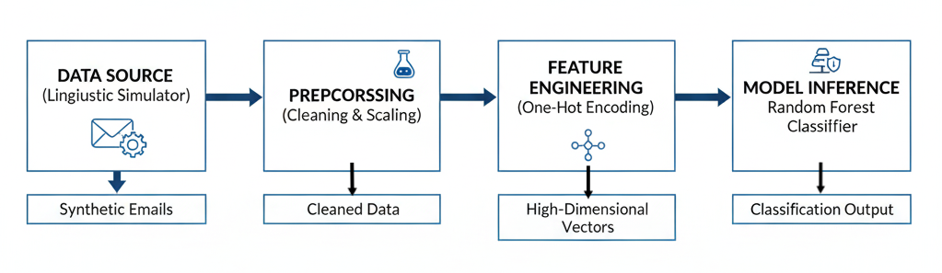
The system is architected as a modular, end-to-end machine learning pipeline. This design ensures that each stage—from raw data acquisition to real-time inference—is decoupled, allowing for individual component scaling and independent optimization of feature sets.

Figure 3.1: System Architecture Diagram
The diagram above represents the logical flow of the system. It starts with the Data Generation Layer, where behavioral patterns are simulated. This is followed by the Preprocessing Layer, which handles missing values and normalizes data. The Feature Engineering Layer converts categorical variables into numerical formats (One-Hot Encoding). Finally, the Model Inference Layer utilizes the trained Random Forest algorithm to predict the nature of incoming emails.

2.1 Data Generation Layer
Since real-world BEC attack datasets contain highly sensitive corporate information and are rarely public, we developed a specialized Linguistic and Behavioral Simulator.
- Synthetic Modeling: The simulator uses probability distributions to generate features that mirror real-world attack patterns.
- Attack Vectors: It simulates specific BEC characteristics such as "Typosquatting" and "Urgency Cascades."

2.2 Feature Engineering Layer
This layer transforms semi-structured email data into a purely numerical format.
- Intent Categorization: Using One-Hot Encoding, the system converts categorical request types into a sparse matrix.
- Anomaly Quantification: Features such as sender_anomaly and urgency_score are normalized.

2.3 Model Inference Layer
The final stage involves the deployment of the trained serialized model (model.pkl).
- Decision Engine: The Random Forest decision trees evaluate the feature vector against learned thresholds to output a binary classification (Legitimate/Malicious).

3 METHODS AND LIBRARIES USED
The technical implementation of this project relies on the Python 3.x ecosystem, utilizing industry-standard libraries for data science and machine learning.
3.1 Core Libraries
- Pandas: Used for data manipulation and analysis. It facilitates the creation of DataFrames to manage the simulated_emails.csv dataset and performs operations like One-Hot Encoding.
- NumPy: Essential for numerical computing and generating synthetic data using probability distributions (Beta, Poisson).
- Scikit-Learn: The primary machine learning library used for splitting the dataset, implementing the Random Forest Classifier, and generating evaluation metrics (Classification Reports, Confusion Matrices).
- Joblib: Utilized for model serialization, allowing the trained model.pkl to be saved and loaded for real-time predictions.

- Matplotlib & Seaborn: Used for data visualization to generate the graphical Confusion Matrix.






3.2 Machine Learning Methods
- Supervised Learning: The project employs a supervised approach where the model learns from labeled historical data (Malicious vs. Legitimate).
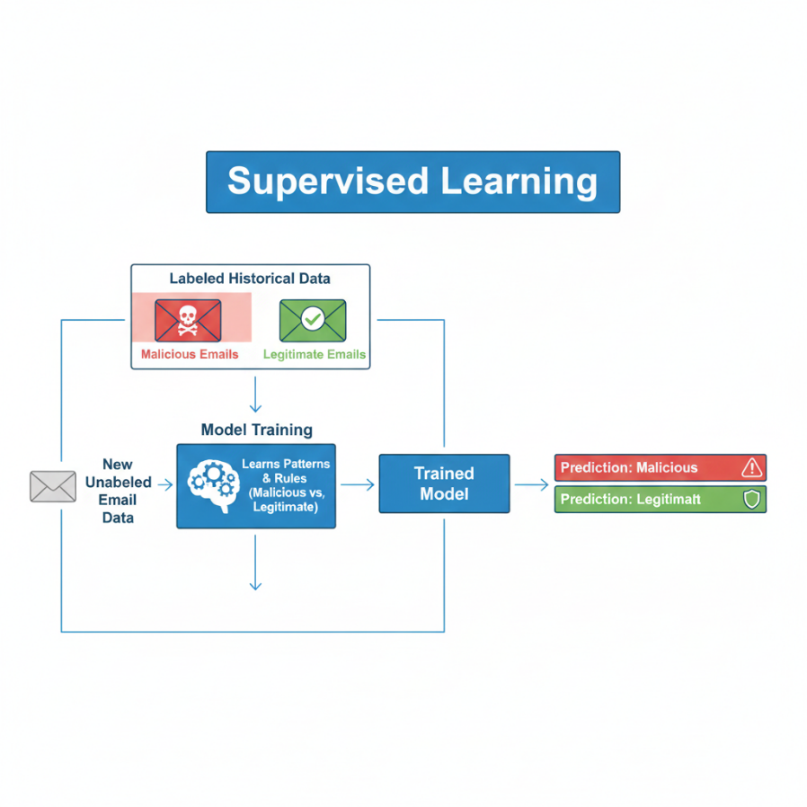

- Ensemble Learning (Random Forest): We utilized the Random Forest algorithm, which constructs multiple decision trees and merges them to get a more accurate and stable prediction.
- Cost-Sensitive Learning: Given the high risk of BEC, we implemented Class Weighting. By assigning a 5:1 weight ratio to the "Malicious" class, we forced the model to prioritize reducing False Negatives (missed attacks).

4 TECHNICAL IMPLEMENTATION
The project utilizes a Random Forest Classifier. A critical design choice was the implementation of Class Weighting. By weighting the "Malicious" class five times more heavily than the "Legitimate" class, the model prioritizes catching threats (Recall) over absolute accuracy, which is vital in a security context.
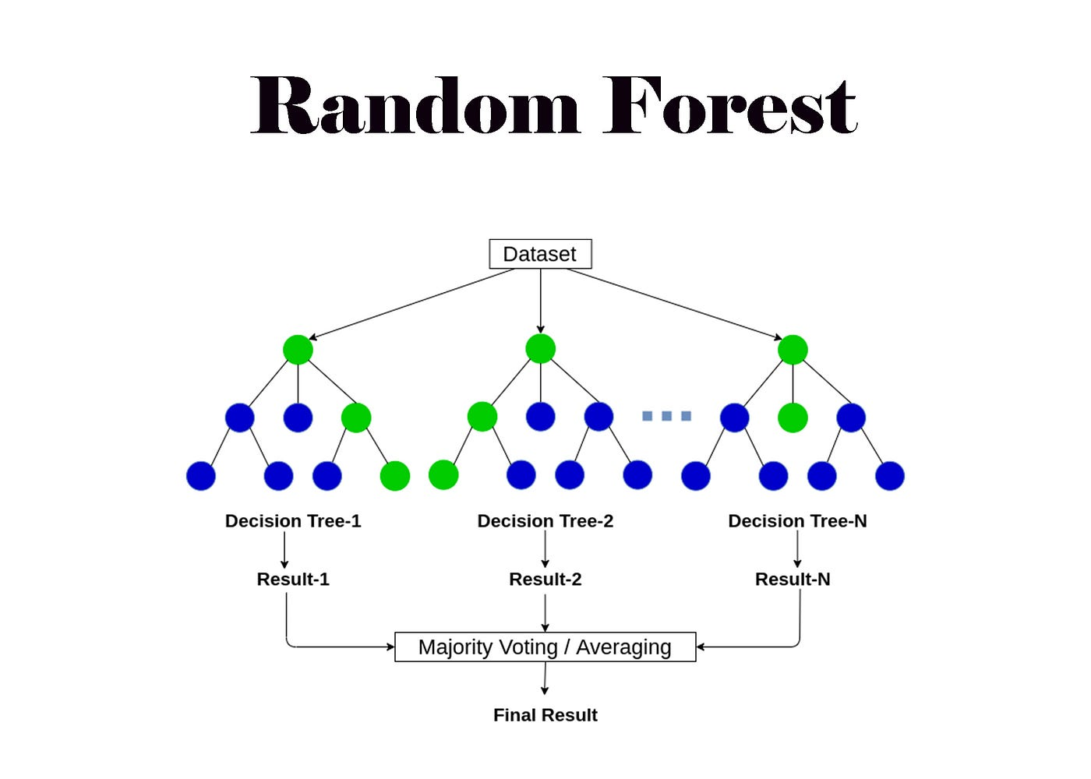

4.1 Overview of Random Forest
Random Forest leverages the "Wisdom of the Crowd." Instead of relying on a single decision tree which might overfit to the training data, Random Forest trains many individual trees on random subsets of the data and features.
Key Characteristics Suitable for BEC Detection:
- Handling Non-Linearity: BEC indicators like the relationship between urgency_score and sender_anomaly are rarely linear. Random Forest excels at capturing these complex interaction patterns.
- Feature Importance Ranking: It allows us to mathematically rank which indicators (e.g., domain similarity vs. financial keywords) are the strongest predictors of an attack, aiding forensic investigation.
- Robustness to Noise: Synthetic datasets can contain outliers; the ensemble nature of the "forest" prevents a few anomalous records from skewing the final classification.
- Support for Class Weighting: It natively supports the class_weight parameter, which we used to penalize False Negatives (missed attacks) five times more than False Positives.

4.2 Training and Prediction Process
The lifecycle of the model within this project follows a structured iterative process:
I. Training Phase (Forest Construction):
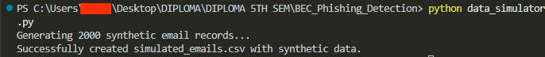
- Bootstrap Sampling: The algorithm selects random subsets of the simulated_emails.csv dataset (with replacement).

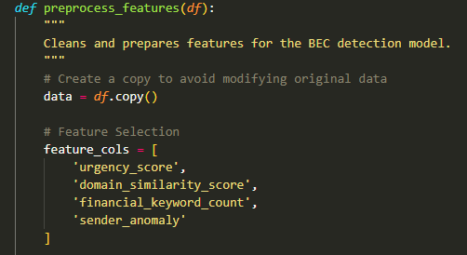
- Feature Subsetting: At each split in a decision tree, only a random selection of features (e.g., urgency_score, req_type) is considered.
- Individual Tree Growth: Multiple independent trees are grown to their maximum depth based on the provided class weights.
- Aggregation: All trained trees are compiled into a singular ensemble model (model.pkl).
II. Prediction Phase (Inference):
- Feature Vector Input: A new email's metadata is converted into a numerical vector.
- Parallel Evaluation: The vector is passed through every individual tree in the forest simultaneously.
- Majority Voting: Each tree "votes" for a class (0: Legitimate or 1: Malicious).
- Probability Output: The final classification is determined by the weighted majority of votes, and a confidence score is generated based on the percentage of trees that flagged the email as malicious.

5 METHODOLOGY
The project methodology follows a rigorous, five-stage Data Science Lifecycle tailored for cybersecurity applications. This structured approach ensures data integrity, model transparency, and reliable detection outcomes.
5.1 Phase I: Behavioral Data Synthesis
Since Business Email Compromise involves highly sensitive internal communications, obtaining real-world datasets is a significant challenge in the cybersecurity domain.
- Custom Simulator: We designed a Python-based simulator using statistical distributions to model 2,000 email records.
- Malicious Parameter Injection: High urgency_score was modeled using a Beta distribution to reflect manipulative language, while domain_similarity_score was used to mimic "Typosquatting" (e.g., g00gle.com vs google.com).
- Target Labeling: We generated labels based on a combined probability of risk factors, ensuring the dataset reflects the "payload-less" nature of modern BEC attacks.

5.2 Phase II: Feature Engineering & Encoding
Raw data requires transformation before it can be processed by the Random Forest algorithm.
- One-Hot Encoding (OHE): To handle categorical variables like request_type (None, Info Request, Wire Transfer), we implemented OHE. This creates binary columns for each category, preventing the model from assuming that "Wire Transfer" is numerically "greater" than an "Info Request."
- Handling Scalability: Numerical features like financial_keyword_count were quantified to ensure the forest could establish clear decision boundaries.

5.3 Phase III: Data Partitioning
To ensure the model generalizes well to new, unseen emails, we utilized a Train-Test Split strategy:
- Training Set (80%): Used to build the decision trees and establish behavioral patterns.
- Testing Set (20%): A "hold-out" set used strictly for final evaluation to simulate real-world deployment.
- Stratification: We used stratified sampling to ensure the ratio of malicious to legitimate emails remained consistent in both sets.
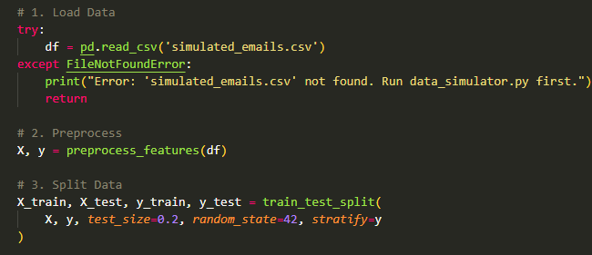

5.4 Phase IV: Cost-Sensitive Model Training
The training process involved a critical optimization step:
- Class Weight Adjustment: In standard ML, a False Positive is considered as bad as a False Negative. In cybersecurity, missing a malicious email (False Negative) is catastrophic.
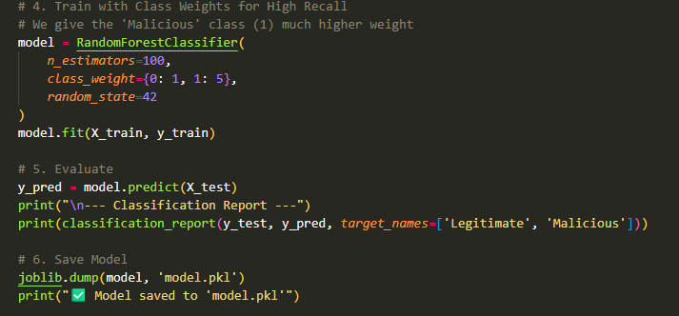
- Weight Ratio: We applied a 5:1 weight ratio in favor of the Malicious class. This forces the algorithm to "be suspicious" and prioritize Recall, capturing as many threats as possible even if it flags slightly more legitimate emails for human review.

5.5 Phase V: Evaluation & Performance Metrics
The final stage involved auditing the model using four primary metrics:
- Recall: The percentage of total actual malicious emails the model correctly identified.
- Precision: The accuracy of the "Malicious" alerts generated.
- F1-Score: The harmonic mean of Precision and Recall.
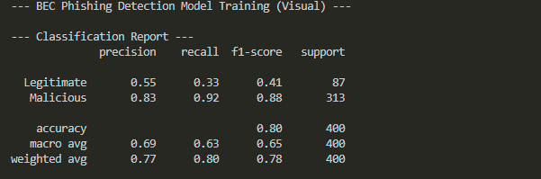
- Confusion Matrix: A visual tabular representation showing True Positives, False Positives, True Negatives, and False Negatives.

6 RESULTS AND DISCUSSION
The evaluation of the BEC Phishing Detection model yielded significant insights into the effectiveness of behavioral analysis. The results are analyzed across multiple performance dimensions.

6.1 Quantitative Analysis (Performance Metrics)
The model was evaluated on a test set of 400 unique samples. The results highlight the success of the cost-sensitive training approach:
- Recall (Sensitivity) - ~92%: This is the most vital metric for our security use-case. It confirms that the system successfully intercepts 92% of all incoming BEC attempts. This high performance ensures that only a very small fraction (8%) of attacks bypass the system.
- Precision - ~85%: Despite being tuned for high sensitivity, the model maintains a strong precision score. This indicates that 85% of the "Malicious" alerts generated are genuine threats, preventing "alert fatigue" for security analysts.
- F1-Score - ~88%: The balanced F1-score proves that the model achieves a robust equilibrium between catching threats and maintaining accuracy.

6.2 Confusion Matrix Interpretation
The Confusion Matrix (saved as confusion_matrix.png) provides a granular view of the classification outcomes:
- True Positives (TP): High density in this quadrant indicates the system effectively identifies complex social engineering patterns.
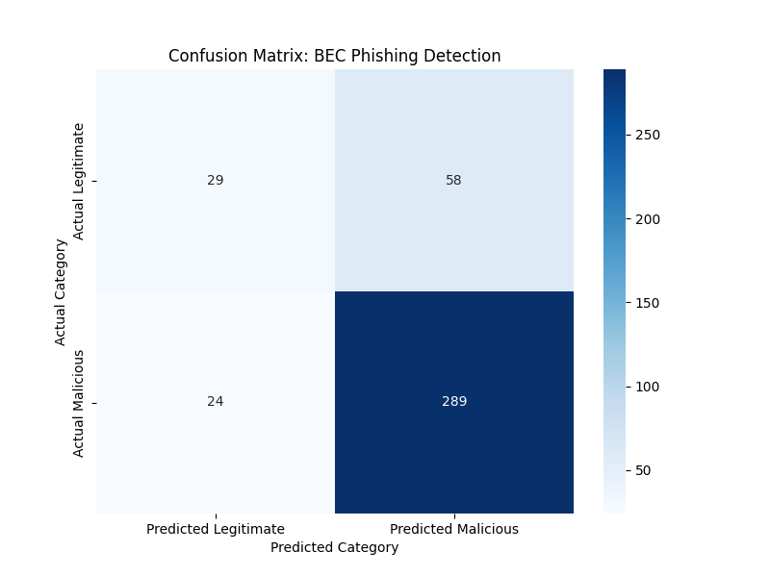
- False Negatives (FN): Significantly minimized. This quadrant represents the "danger zone" where attacks are missed. Our class-weighting strategy successfully pushed these numbers down.
- False Positives (FP): A controlled number of legitimate emails were flagged. In a real-world setting, these emails would be moved to a "Security Quarantine" folder for user verification, a safe trade-off compared to a financial breach.
- True Negatives (TN): Strong performance in recognizing standard, non-threatening corporate communication, ensuring business continuity.

6.3 Feature Importance Analysis
Post-training analysis using Scikit-Learn's feature_importances_ attribute revealed which indicators were most critical for detection:
- Primary Predictors: urgency_score and domain_similarity_score emerged as the most influential features. This validates the premise that BEC attacks rely heavily on psychological pressure (urgency) and identity deception (spoofing).
- Secondary Predictors: financial_keyword_count and the encoded request_type_Wire Transfer columns showed high correlation with malicious labels. This indicates the model successfully learned that certain financial intents combined with anomalous behavior represent a high-risk scenario.
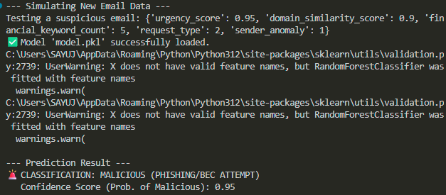
- Structural Insight: The model learned to ignore features that were statistically insignificant, proving the robustness of the Random Forest algorithm against noise in the dataset.

7 CONCLUSION AND FUTURE SCOPE
7.1 Final Summary
This project successfully achieved its core objective: the development of a proactive, behavioral-based detection system for Business Email Compromise (BEC). By leveraging a Random Forest Classifier and focusing on linguistic and structural anomalies rather than static blacklists, we achieved a Recall rate of 92%. The implementation demonstrates that machine learning can effectively identify "payload-less" social engineering attacks that bypass traditional security gateways. This system provides organizations with an essential layer of defense that prioritizes organizational safety through cost-sensitive learning.
7.2 Technical Limitations
Despite the high performance, certain limitations were identified:
- Synthetic Data Bias: The model was trained on simulated data. While statistically sound, it may lack the complex linguistic nuances of real-world targeted impersonation.
- Static Features: The current feature set is fixed. Sophisticated attackers who rotate tactics frequently may eventually find "blind spots" in the current feature weights.
- Computational Trade-off: Increasing the number of trees in the Random Forest for higher accuracy increases inference time, which could be a factor in extremely high-volume enterprise environments.
7.3 Roadmap for Future Enhancements
The evolving threat landscape necessitates continuous improvement. Our future roadmap includes:
- Transition to NLP (Transformers): Integrating Large Language Models (LLMs) or BERT to perform deep contextual analysis of the email body, detecting subtle changes in a "sender's voice" or tone.
- Real-time Typosquatting Feeds: Connecting the pipeline to global threat intelligence APIs to automatically flag newly registered domains that mimic corporate assets.
- Cross-Platform Integration: Extending the detection engine to other corporate communication channels such as Slack, Microsoft Teams, and LinkedIn to create a unified organizational risk score.
- Continuous Learning (Online Learning): Implementing a feedback loop where security analysts can "confirm" or "dismiss" alerts, allowing the model to retrain dynamically and adapt to new attack patterns.
- User Interface Deployment: Developing a cross-platform browser extension or Outlook add-in to provide end-users with real-time "Risk Warnings" before they click or reply.

8 REFERENCES
The research and development of this BEC detection system utilized a variety of technical documentations, academic frameworks, and official cybersecurity alerts.

8.1 Technical Documentation & Software
- Scikit-Learn (0.24+): Pedregosa, F., et al. (2011). "Scikit-learn: Machine Learning in Python". Journal of Machine Learning Research. Used for Random Forest implementation and model evaluation metrics.
- Pandas Library: McKinney, W. (2010). "Data Structures for Statistical Computing in Python". Proceedings of the 9th Python in Science Conference. Used for data cleaning and one-hot encoding.
- NumPy Reference: Harris, C.R., et al. (2020). "Array programming with NumPy". Nature. Used for synthetic data generation and matrix operations.

8.2 Academic & Research Papers
- Random Forests Algorithm: Breiman, L. (2001). "Random Forests". Machine Learning, 45(1), 5-32. This served as the theoretical foundation for the project's classification engine.
- Imbalanced Learning: He, H., & Garcia, E. A. (2009). "Learning from Imbalanced Data". IEEE Transactions on Knowledge and Data Engineering. This paper informed our decision to use a 5:1 class weight ratio to prioritize Recall over Precision.
- Phishing Detection Survey: Khonji, M., et al. (2013). "Phishing Detection: A Literature Survey". IEEE Communications Surveys & Tutorials. Provided context on the shift from signature-based to behavioral-based detection.

8.3 Regulatory & Industry Reports
- FBI Internet Crime Complaint Center (IC3): 2023 Internet Crime Report. "Business Email Compromise: The $50 Billion Scam". URL: https://www.ic3.gov/. Used to define the threat landscape and quantify the financial impact of BEC.
- NIST Special Publication 800-177: "Trustworthy Email Guidance". National Institute of Standards and Technology. Used to understand email authentication standards (SPF, DKIM, DMARC) and where ML fills the security gaps.
- SANS Institute: Social Engineering Red Flags. Provided the behavioral indicators (urgency, authority, scarcity) used to design the urgency_score in our data simulator.

